How to resolve the conflict issue.

If you see a merge conflict in Gerrit UI, you can follow below step to resolve locally & push to central repo.

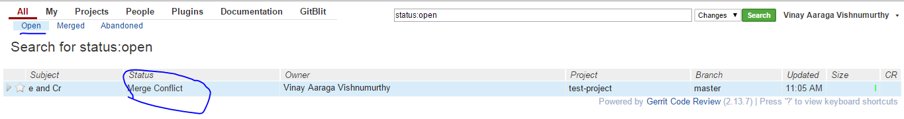

1. And you try updating code base with git pull & still can’t resolve ☹ , so abort merge & proceed to manual merge & see if re-basing resolves, else need to manually resolve.

8900874@V6022550 MINGW64 /c/Users/8900874/Vinay/Projects/tmp/252/test-project/TstDir (master)

$ git pull

remote: Counting objects: 7, done

remote: Finding sources: 100% (4/4)

remote: Total 4 (delta 1), reused 4 (delta 1)

Unpacking objects: 100% (4/4), done.

From ssh://10.59.151.252:29418/test-project

4ac82c6..c57366d  master     -> origin/master

Auto-merging TstDir/text.txt

CONFLICT (content): Merge conflict in TstDir/text.txt

Automatic merge failed; fix conflicts and then commit the result.

8900874@V6022550 MINGW64 /c/Users/8900874/Vinay/Projects/tmp/252/test-project/TstDir (master|MERGING)

$ git merge --abort

8900874@V6022550 MINGW64 /c/Users/8900874/Vinay/Projects/tmp/252/test-project/TstDir (master)

1. Get change number from gerrit ( eg : [http://10.59.151.252:9100/#/c/**43**/](http://10.59.151.252:9100/#/c/43/) ) & proceed to merging locally first with rebase approach first

8900874@V6022550 MINGW64 /c/Users/8900874/Vinay/Projects/tmp/252/test-project/TstDir (master)

$ git ls-remote | grep 43/

From ssh://Vinay@10.59.151.252:29418/test-project

4fb2b5e6cd1b454b07cafaab6c9b6554fa349893        refs/changes/43/43/1

8900874@V6022550 MINGW64 /c/Users/8900874/Vinay/Projects/tmp/252/test-project/TstDir (master)

$ git fetch <http://10.59.151.252:9100/test-project> refs/changes/43/43/1 && git checkout FETCH_HEAD

From <http://10.59.151.252:9100/test-project>

* branch            refs/changes/43/43/1 -> FETCH_HEAD

Note: checking out 'FETCH_HEAD'.

You are in 'detached HEAD' state. You can look around, make experimental

changes and commit them, and you can discard any commits you make in this

state without impacting any branches by performing another checkout.

If you want to create a new branch to retain commits you create, you may

do so (now or later) by using -b with the checkout command again. Example:

git checkout -b <new-branch-name>

HEAD is now at 4fb2b5e... e and Cr

8900874@V6022550 MINGW64 /c/Users/8900874/Vinay/Projects/tmp/252/test-project/TstDir ((4fb2b5e...))

$ git rebase origin/master

First, rewinding head to replay your work on top of it...

Applying: e and Cr

Using index info to reconstruct a base tree...

M       TstDir/text.txt

Falling back to patching base and 3-way merge...

Auto-merging TstDir/text.txt

CONFLICT (content): Merge conflict in TstDir/text.txt

error: Failed to merge in the changes.

Patch failed at 0001 e and Cr

The copy of the patch that failed is found in: .git/rebase-apply/patch

When you have resolved this problem, run "git rebase --continue".

If you prefer to skip this patch, run "git rebase --skip" instead.

To check out the original branch and stop rebasing, run "git rebase --abort".

1. If simple rebasing did not resolve conflict, you need to resolve manually & continue rebaseing

8900874@V6022550 MINGW64 /c/Users/8900874/Vinay/Projects/tmp/252/test-project/TstDir (detached HEAD|REBASE 1/1)

$ vi text.txt

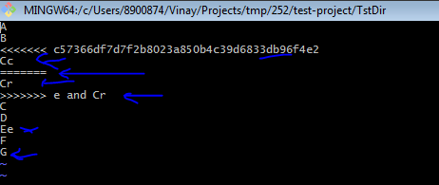

8900874@V6022550 MINGW64 /c/Users/8900874/Vinay/Projects/tmp/252/test-project/TstDir (detached HEAD|REBASE 1/1)

$ git add text.txt

8900874@V6022550 MINGW64 /c/Users/8900874/Vinay/Projects/tmp/252/test-project/TstDir (detached HEAD|REBASE 1/1)

$ git rebase --continue

Applying: e and Cr

8900874@V6022550 MINGW64 /c/Users/8900874/Vinay/Projects/tmp/252/test-project/TstDir ((6b7f978...))

$ git status

HEAD detached from FETCH_HEAD

nothing to commit, working directory clean

8900874@V6022550 MINGW64 /c/Users/8900874/Vinay/Projects/tmp/252/test-project/TstDir ((6b7f978...))

$ git commit --amend

[detached HEAD 7ae5667] e and Cr

Date: Mon Dec 4 10:05:54 2017 +0000

1 file changed, 1 insertion(+), 1 deletion(-)

8900874@V6022550 MINGW64 /c/Users/8900874/Vinay/Projects/tmp/252/test-project/TstDir ((7ae5667...))

$ git push origin HEAD:refs/for/master

Counting objects: 4, done.

Delta compression using up to 2 threads.

Compressing objects: 100% (2/2), done.

Writing objects: 100% (4/4), 382 bytes | 0 bytes/s, done.

Total 4 (delta 1), reused 0 (delta 0)

remote: Resolving deltas: 100% (1/1)

remote: Processing changes: updated: 1, refs: 1, done

remote:

remote: Updated Changes:

remote:   <http://10.59.151.252/43> e and Cr

remote:

To ssh://Vinay@10.59.151.252:29418/test-project

* [new branch]      HEAD -> refs/for/master

8900874@V6022550 MINGW64 /c/Users/8900874/Vinay/Projects/tmp/252/test-project/TstDir ((7ae5667...))

$

1. Once commit is amended & pushed, conflict will go away & you need to get your code approved

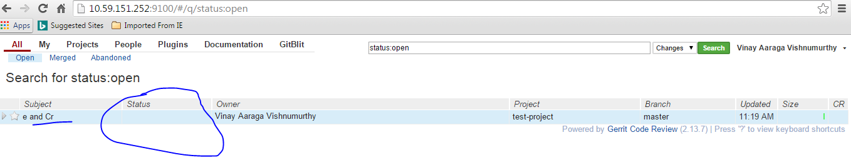

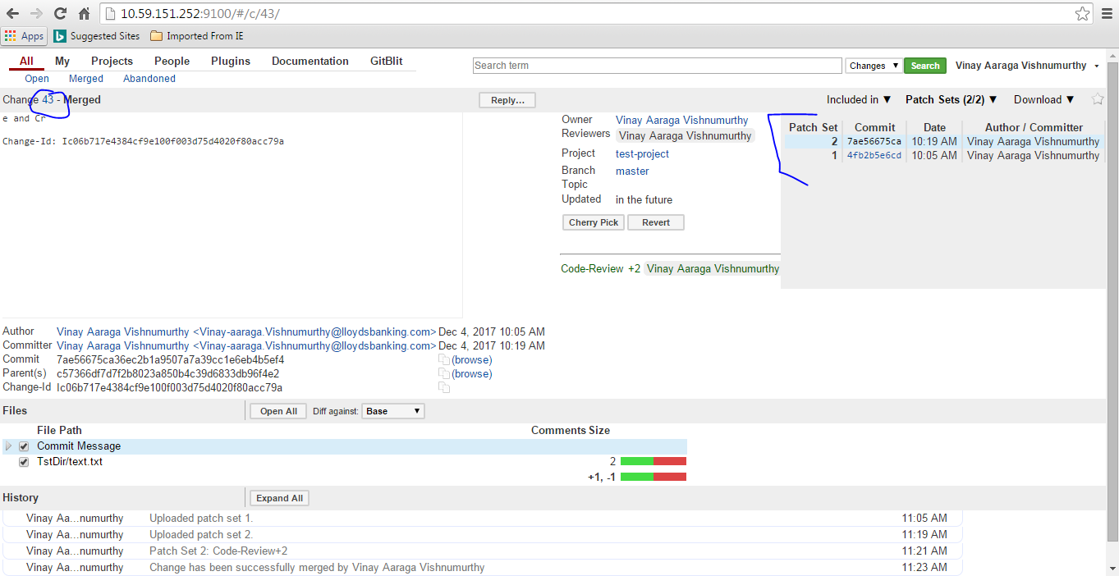

1. Post approval & merge is complete, you can reset master to update local tree ( **note** with reset hard options locally modified files will get removed. So you can backup first )

8900874@V6022550 MINGW64 /c/Users/8900874/Vinay/Projects/tmp/252/test-project/TstDir ((7ae5667...))

$ git checkout master

Warning: you are leaving 1 commit behind, not connected to

any of your branches:

7ae5667 e and Cr

If you want to keep it by creating a new branch, this may be a good time

to do so with:

git branch <new-branch-name> 7ae5667

Switched to branch 'master'

Your branch and 'origin/master' have diverged,

and have 1 and 1 different commit each, respectively.

(use "git pull" to merge the remote branch into yours)

8900874@V6022550 MINGW64 /c/Users/8900874/Vinay/Projects/tmp/252/test-project/TstDir (master)

$ git reset origin/master

Unstaged changes after reset:

M       TstDir/text.txt

8900874@V6022550 MINGW64 /c/Users/8900874/Vinay/Projects/tmp/252/test-project/TstDir (master)

$ git reset --hard HEAD

HEAD is now at c57366d Cc and G

8900874@V6022550 MINGW64 /c/Users/8900874/Vinay/Projects/tmp/252/test-project/TstDir (master)

$ git clean -f -d

8900874@V6022550 MINGW64 /c/Users/8900874/Vinay/Projects/tmp/252/test-project/TstDir (master)

$ git pull

From ssh://10.59.151.252:29418/test-project

c57366d..7ae5667  master     -> origin/master

Updating c57366d..7ae5667

Fast-forward

TstDir/text.txt | 2 +-

1 file changed, 1 insertion(+), 1 deletion(-)

8900874@V6022550 MINGW64 /c/Users/8900874/Vinay/Projects/tmp/252/test-project/TstDir (master)

$ cat text.txt

A

B

Cc

C

D

Ee

F

G

8900874@V6022550 MINGW64 /c/Users/8900874/Vinay/Projects/tmp/252/test-project/TstDir (master)

$ git pull